The Science of Laziness

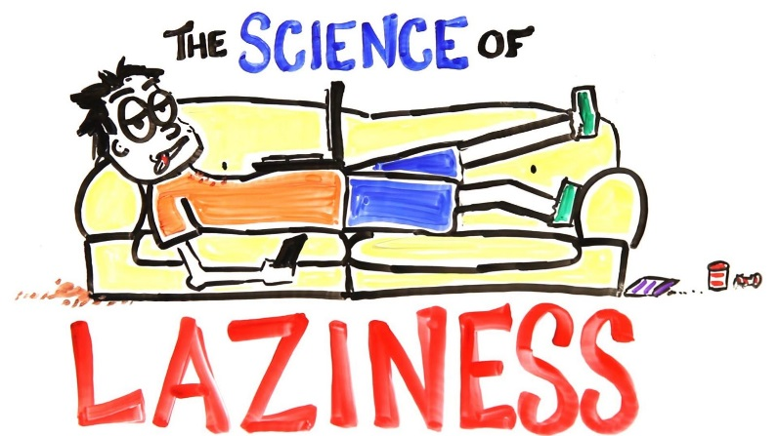

Pirkei Avos 2:15
Rabbi Tarfon would say: The day is short, the work is much, the workers are lazy, the reward is great, and the Master is pressing.

Pirkei Avos 5:23
Judah the son of Teima would say: Be bold as a leopard, light as an eagle, swift as a deer, and strong as a lion, to carry out the will of your Father in Heaven.

Mishlei (24:30-32)
By the fields of a lazy man I passed and by the vineyard of a man without sense (literally: lacking heart). And behold, thistles had grown all over it; nettles had covered its surface, and its stone fence had been torn down.
And I, myself, saw; I applied my heart; I saw and learned a lesson.

Rabbi Y. Salanter
Time is not money. Time is life.

Pirkei Avos 1:1
...Be deliberate in judging...

#1 Define laziness!
#2
Question: What is the root of laziness?

#3
The Students’ Obligations, Rabbi K. Shapira
Laziness is the most harmful and most widespread disease…

Question: What is SO bad about laziness?

#4
The Students’ Obligations, Rabbi K. Shapira
There are two levels of laziness.
- Regular laziness - when a person doesn't want to do anything,
- Lethargy – a lesser form of laziness – this person functions when there is some action to be accomplished, but essentially is not an achiever... is interested only in accomplishing things superficially and invests neither effort nor thoroughness in what he does.

...Still, although the malady of laziness is worse than that of lethargy, it is harder to cure one who is lethargic than one who is lazy…

Questions: What could be the reason for it?
Is there anything else about lethargy that is worse than laziness?

#5
Rabbi Chaim Vital (master of Jewish mysticism)
Laziness comes from atzvus (unhappiness, low spirits, melancholy, depression).

Question: What is the connection between them?
#6
Rabbi E. Dessler
There are two types of laziness
- Laziness in action – Person uses his mind to find excuses not to act. Requires creative thinking.
- Intellectual laziness – Person doesn't want to think things through, acts in haste. Often sin comes from this type.

Question: How can you tell if your calculations concerning a plan of action actually stem from laziness?

#7
Sefer HaChinuch, Mitzvah 16 (explaining the reason why there are so many mitzvos (commandments) in Judaism)
Outward actions have the power to shape one’s inner character. The mitzvos are those actions which will guarantee the improvement of one’s character. A person is influenced by his actions, and his heart and thoughts follow the acts he does whether they are good or bad. Even one who is a completely wicked person, who constantly thinks of doing bad deeds, if he is inspired for the better and puts time into fulfilling Torah and mitzvos, even if it is not for the sake of Heaven, he will turn to the good and he will overcome his Evil Inclination through the power of these actions, since the heart follows the actions a person does. Similarly, even if one is a completely righteous person who desires Torah and mitzvos but always involves himself in bad deeds … after a certain amount of time he will become a wicked person, for we know, and it is true, that every man is affected by his actions.

Question: Based on this principle, what could be ways to deal with one's laziness?

#8
Question: What’s one thing you learned today that you can apply in your life?

